Shell Scripting :

1. String Concatenation with echo

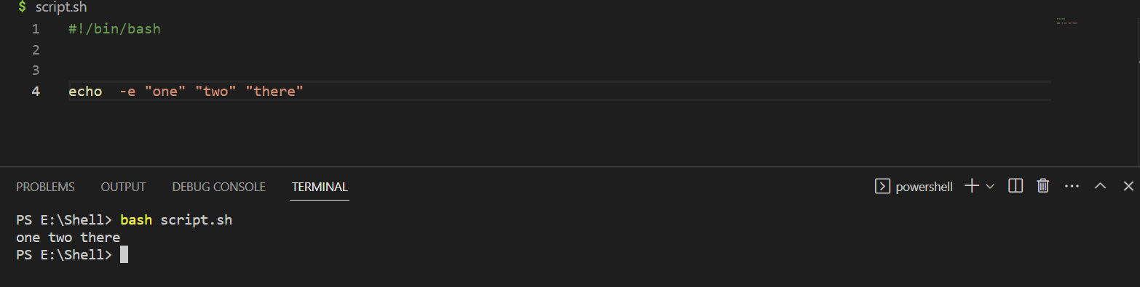

1. String Continuation Character :

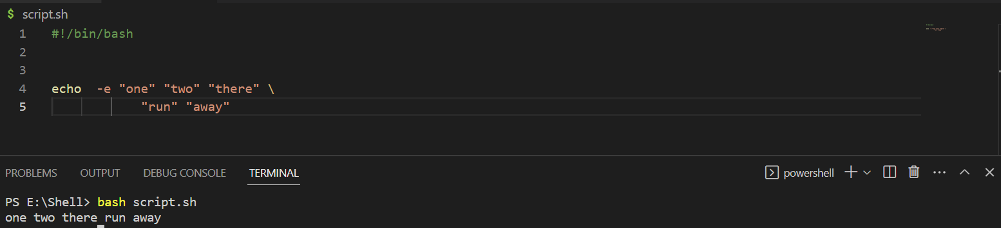

1. Echo with TAB characters :

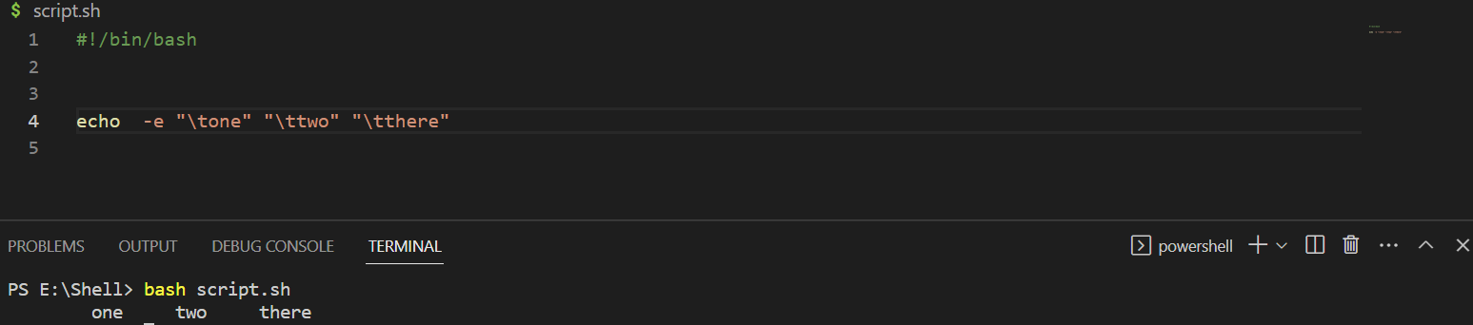

1. Echo with Newline Characters:

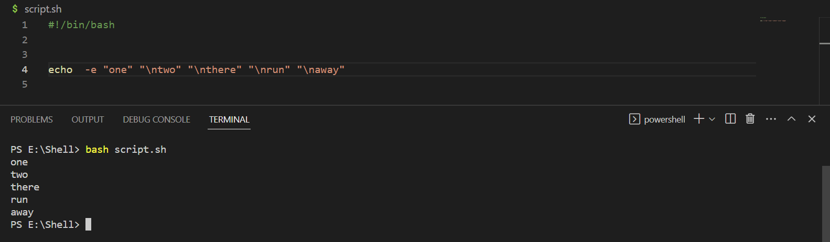

1. Echo with -X command to display all commands:
2. Printing strings that contain single quotes :

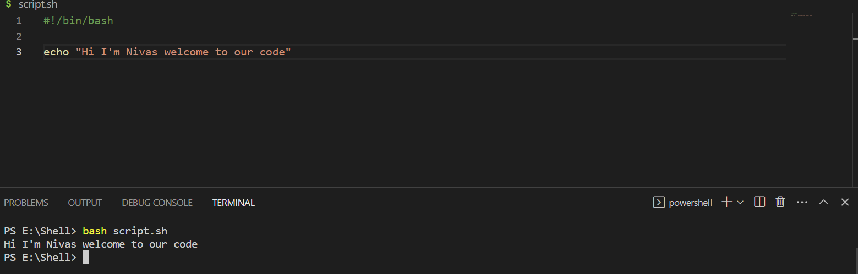

1. Printing strings that contain Double quotes :

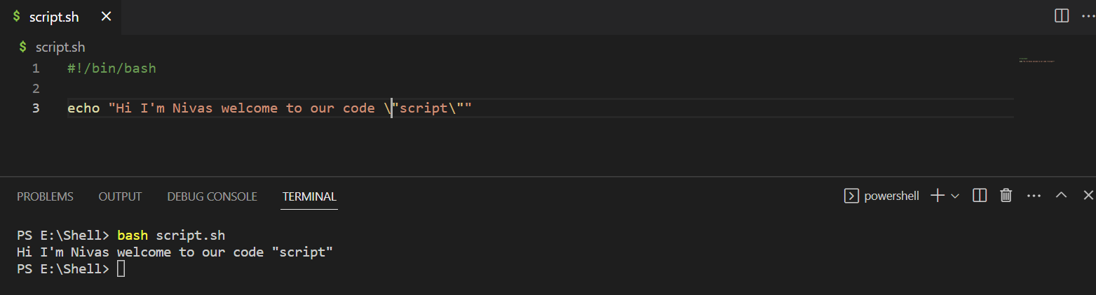

1. Write a File from inside a Script :

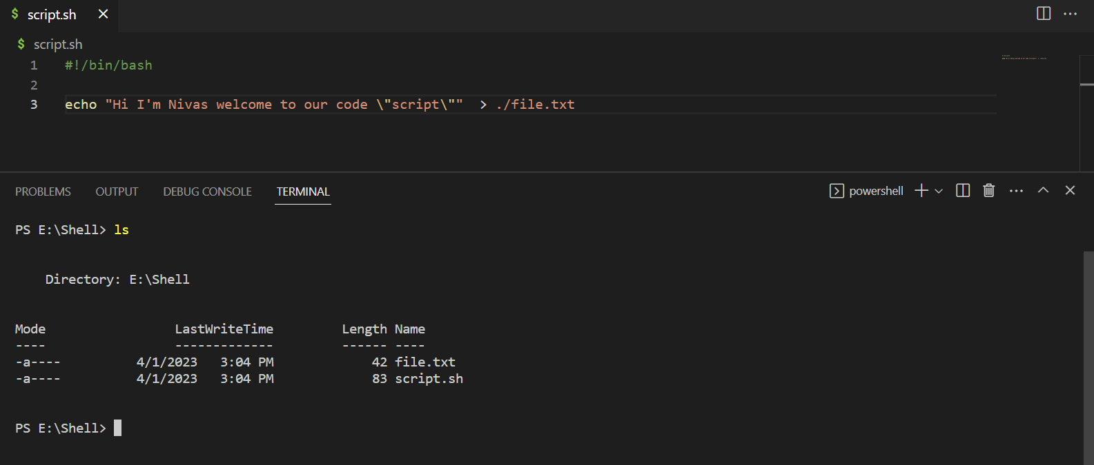

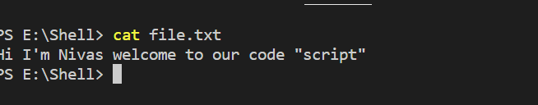

1. Overwrite to a file from inside the script :

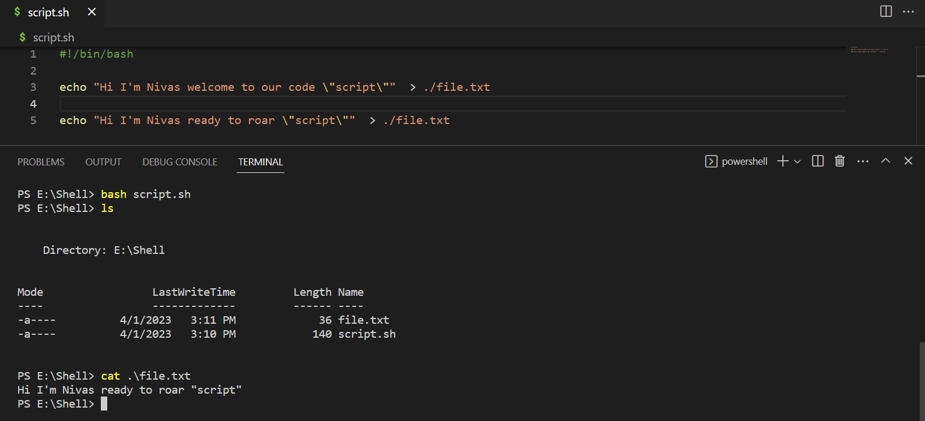

1. Append to file inside a Script :

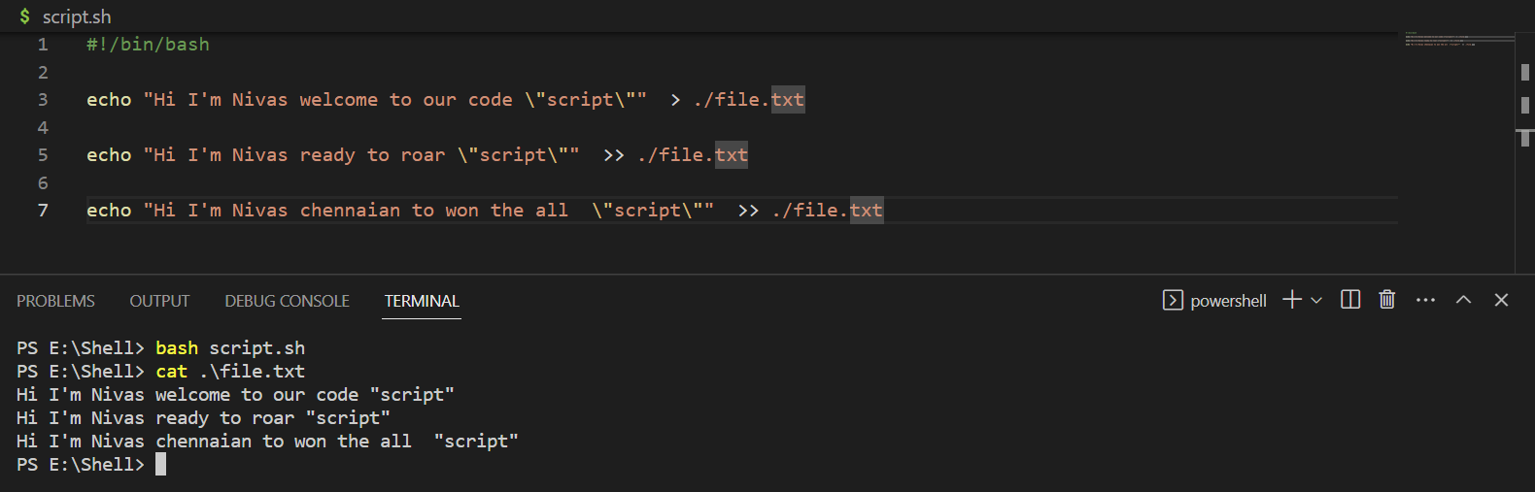

1. Single line Comments :

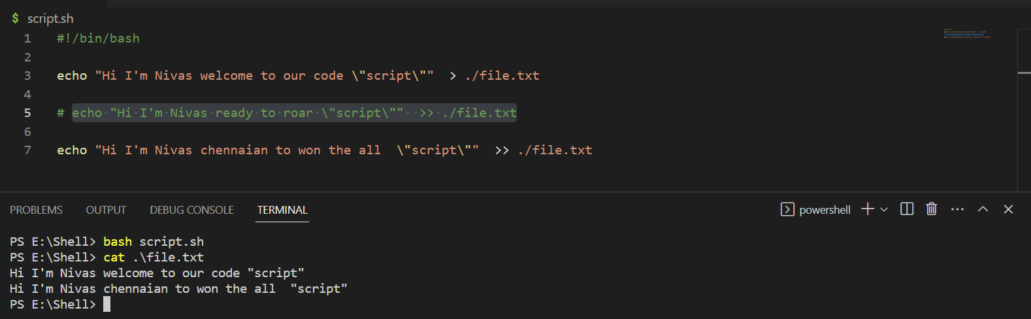

1. Comments from middle of the line :

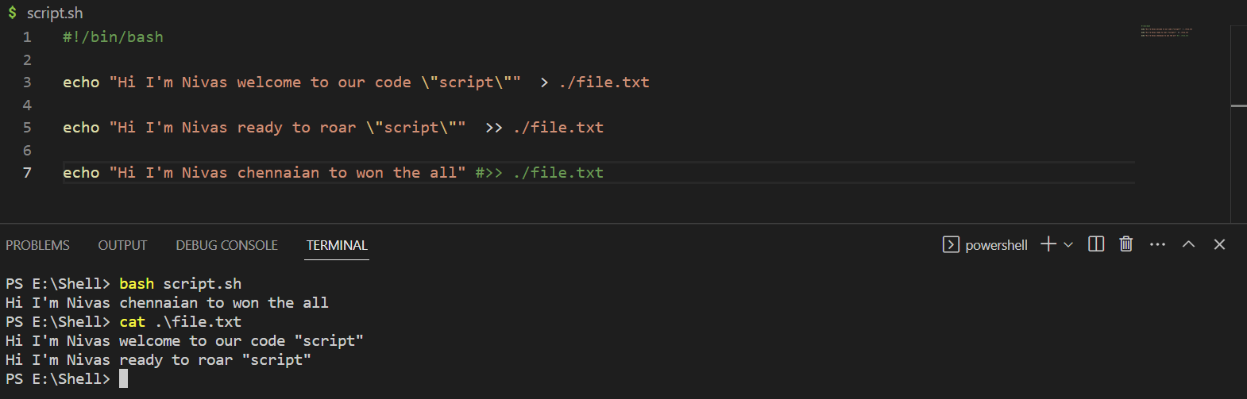

1. Multi line comments using here docs :

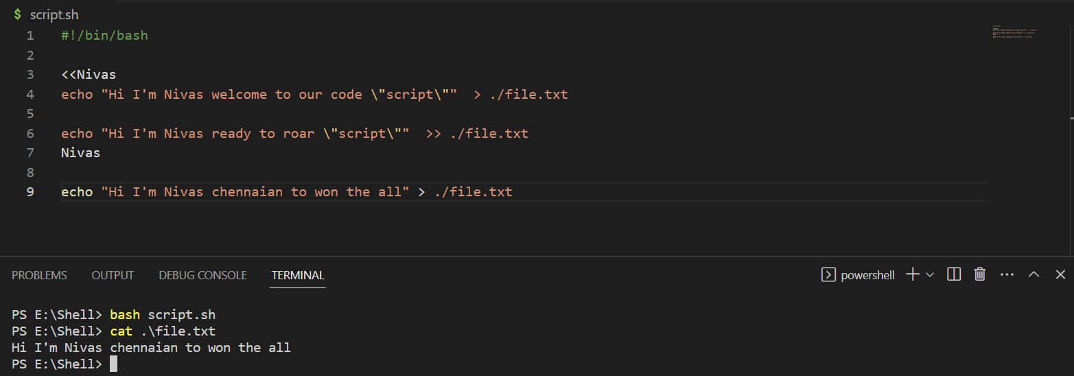

1. Simple Variable usage :

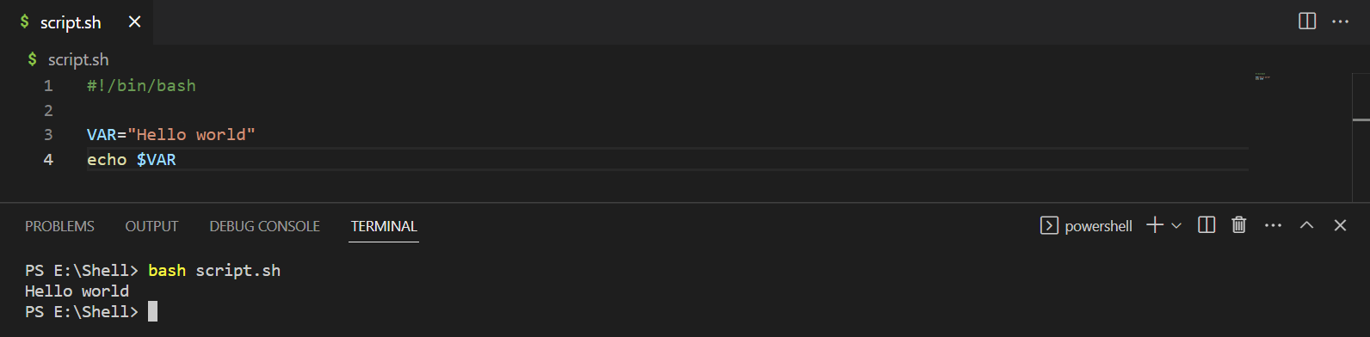

1. Multi word Variable combinations with quotes :

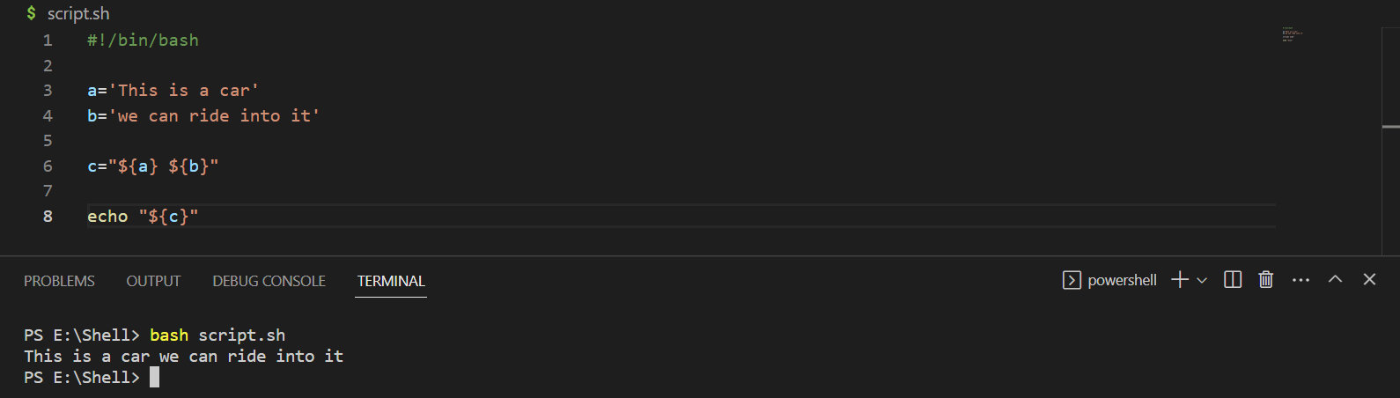

1. HOME Variable:

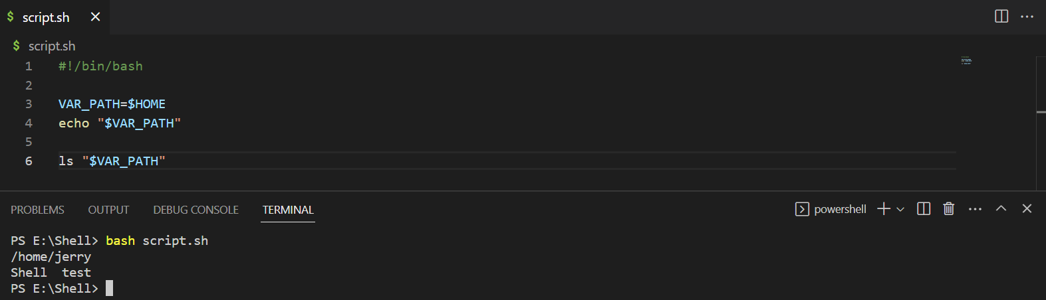

1. USER variable:

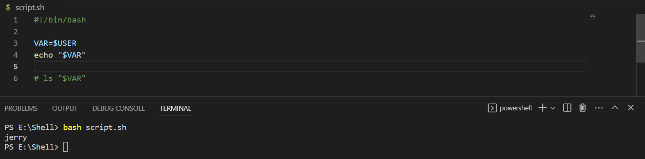

1. Echo $HOME variable with Escape to avoid expansion :

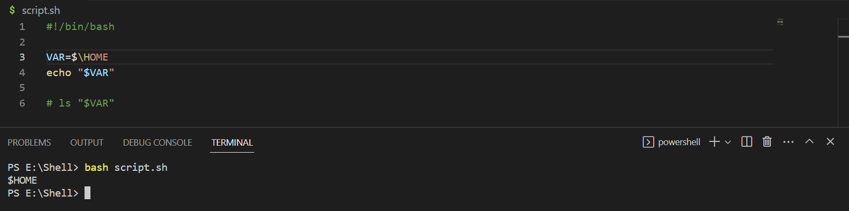

1. Writing to file in HOME Directory using $HOME environment variable:

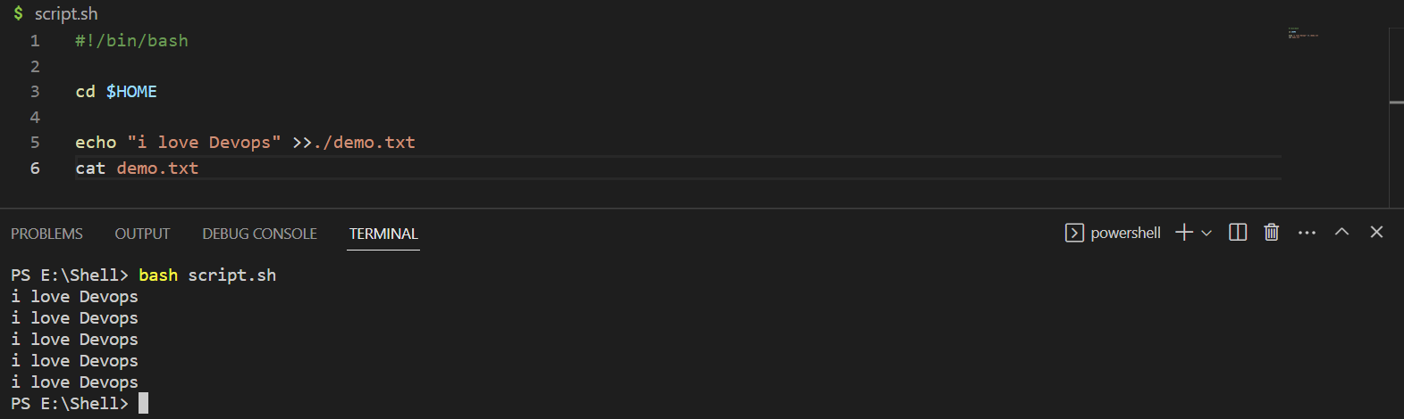

1. Simple TOUCH command :

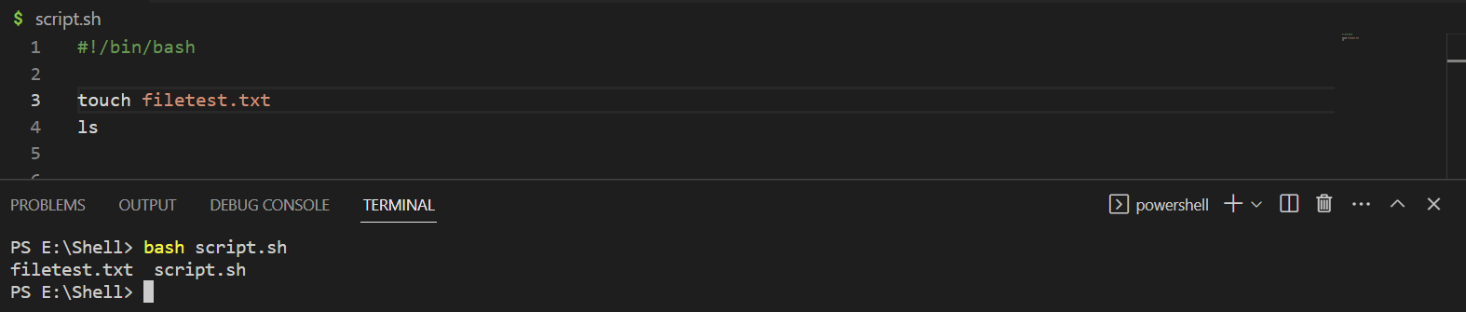

1. Create a Symbol link , write to Linked file, Cat Link file:

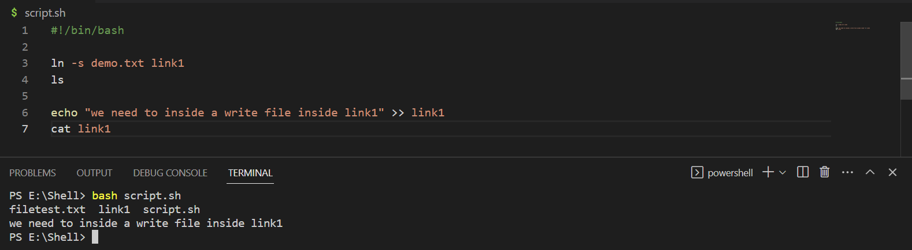

1. Chmod command, Make executable :

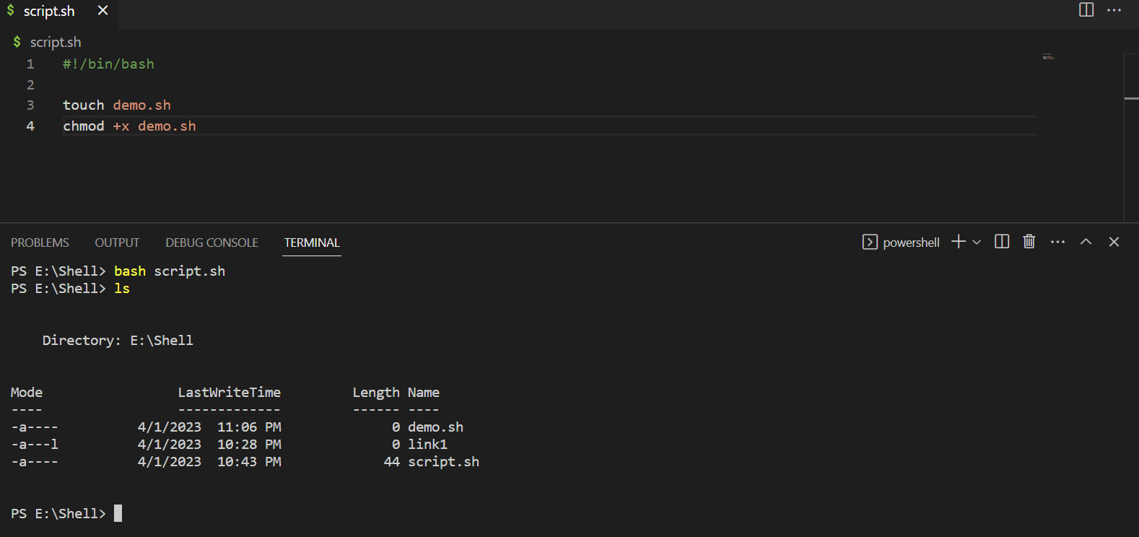

1. Chmod command, Make not-writeable command try to write in it.

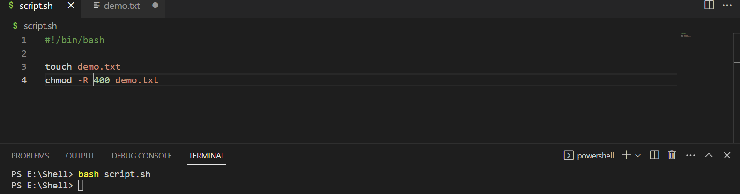



1. Chmod file to different USER, run ls before and after:

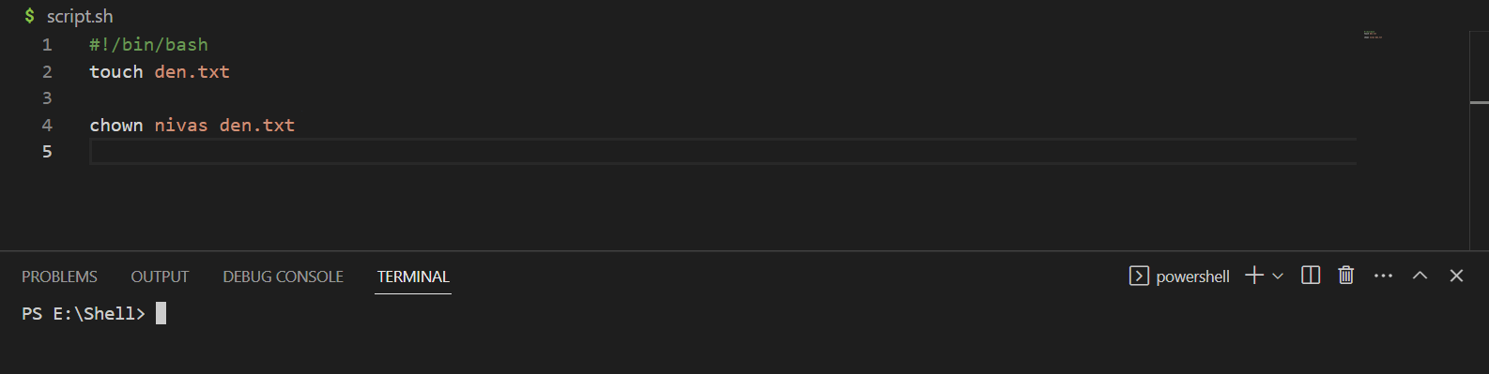

1. Underscore variable, touch file, use underscore variable to touch append to it:

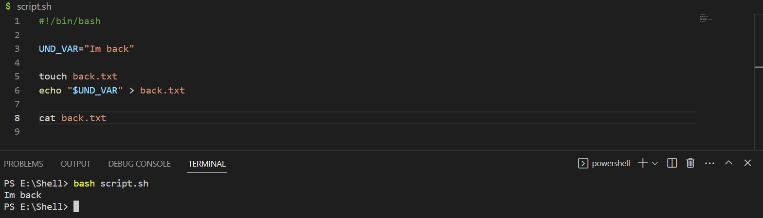

1. Let command Arthimetic:

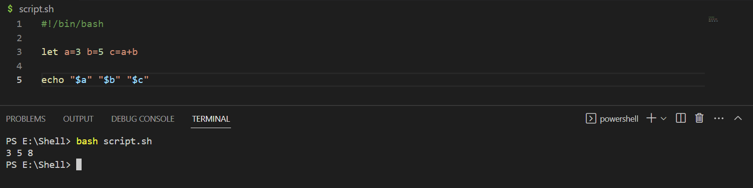

1. 4 basic operators add, subract, multiply, div

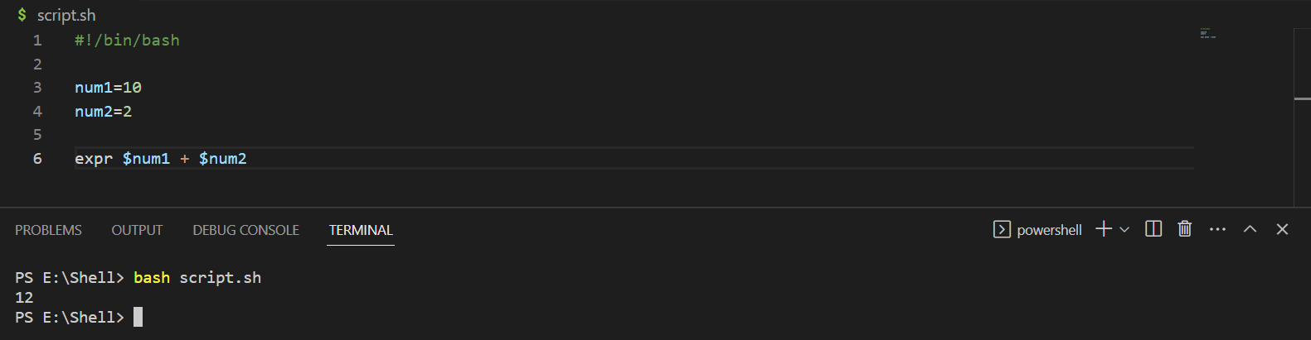

1. Increment a Variable 3 Times with increment operator

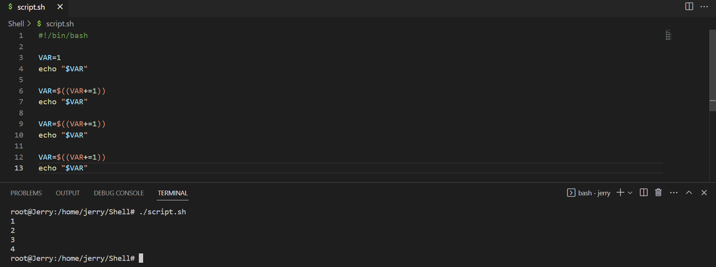

1. Decrement a Variable 3 Times with decrement operator:

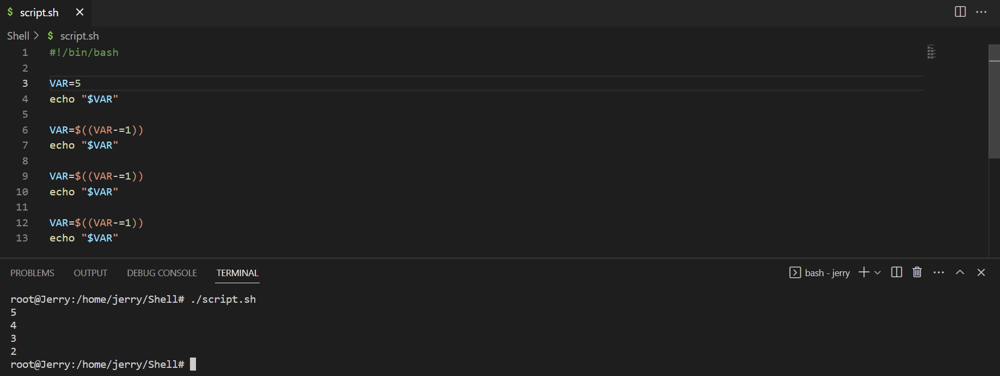

1. Echo Number to exponent of Second Number:

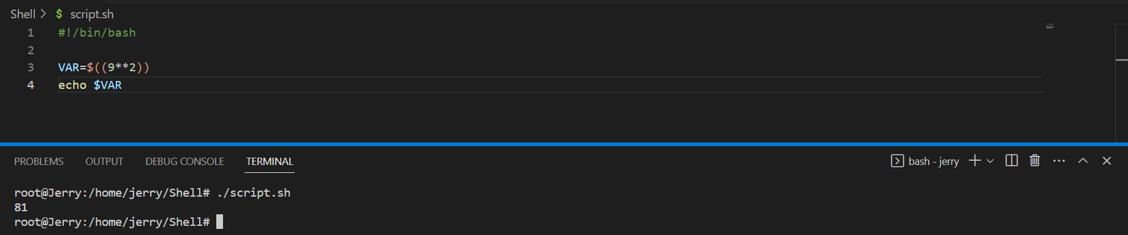

1. Combine 2 strings in one line with variables :

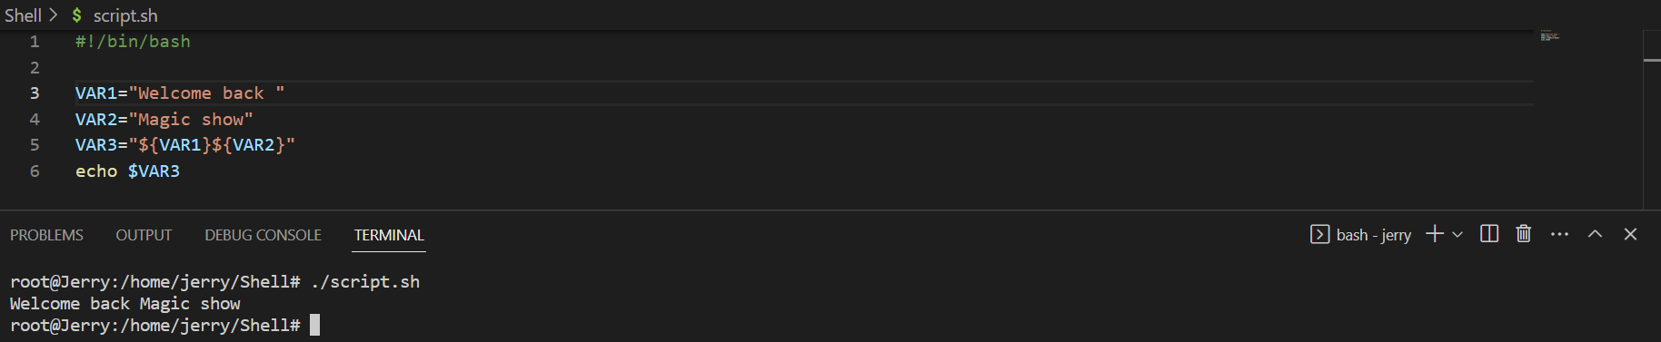

1. Plus equal operator combine 2 strings:

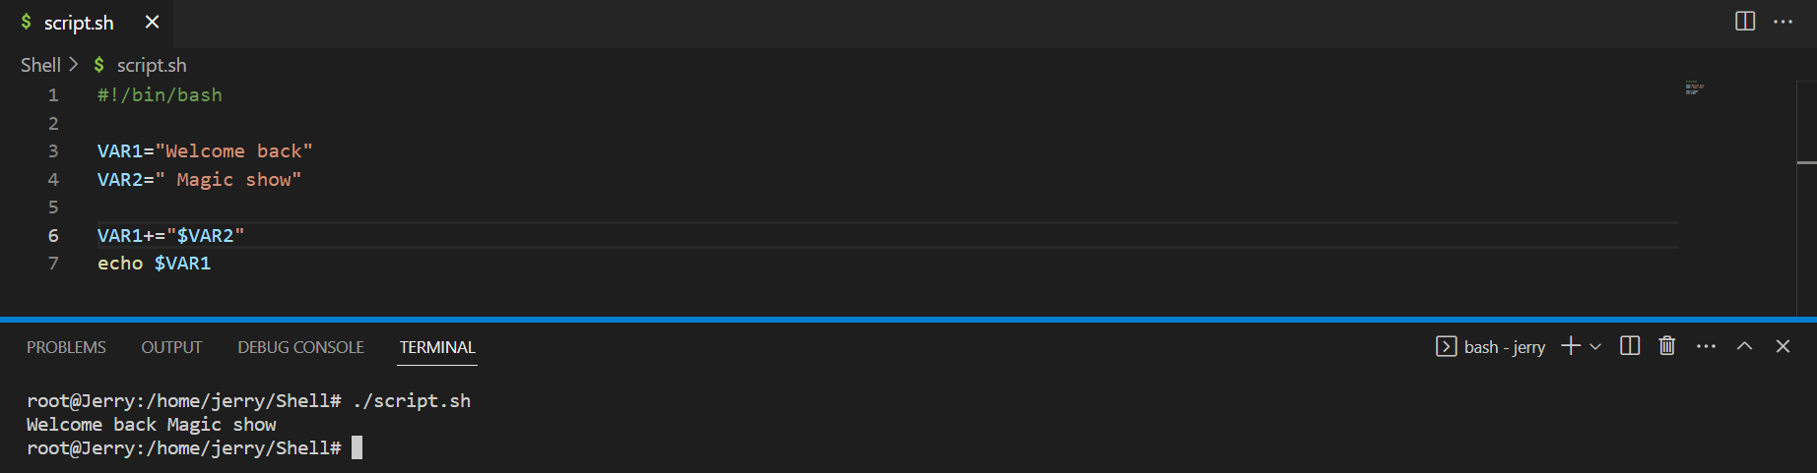

1. Create Multi Line Strings with variable with heredocs :

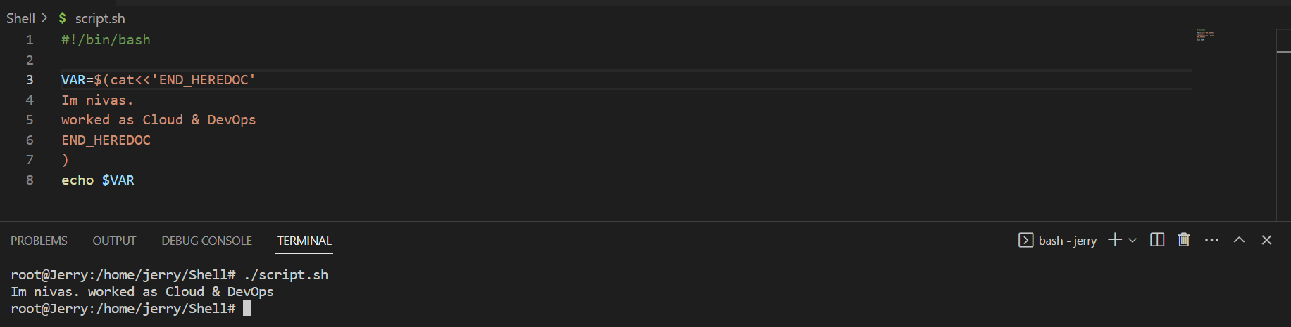

1. Cat Multi line HEREDOC txt :

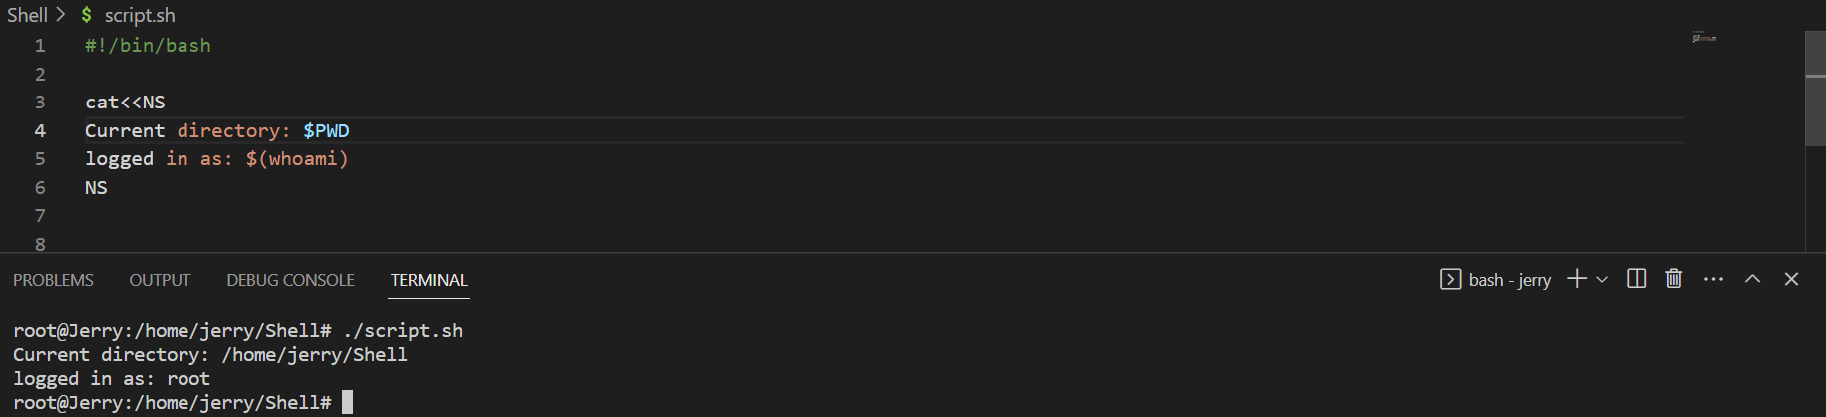

1. If Conditional statement :

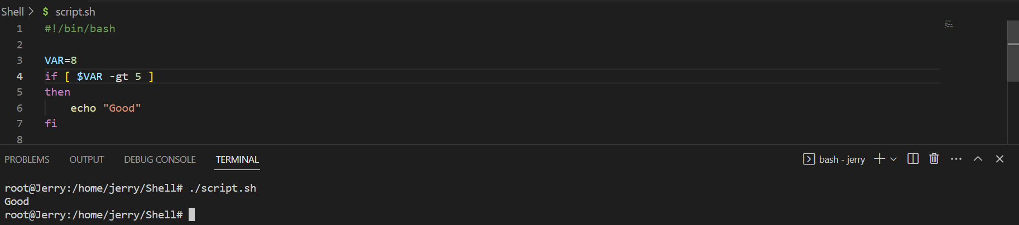

1. IF Elif Else conditional statement :

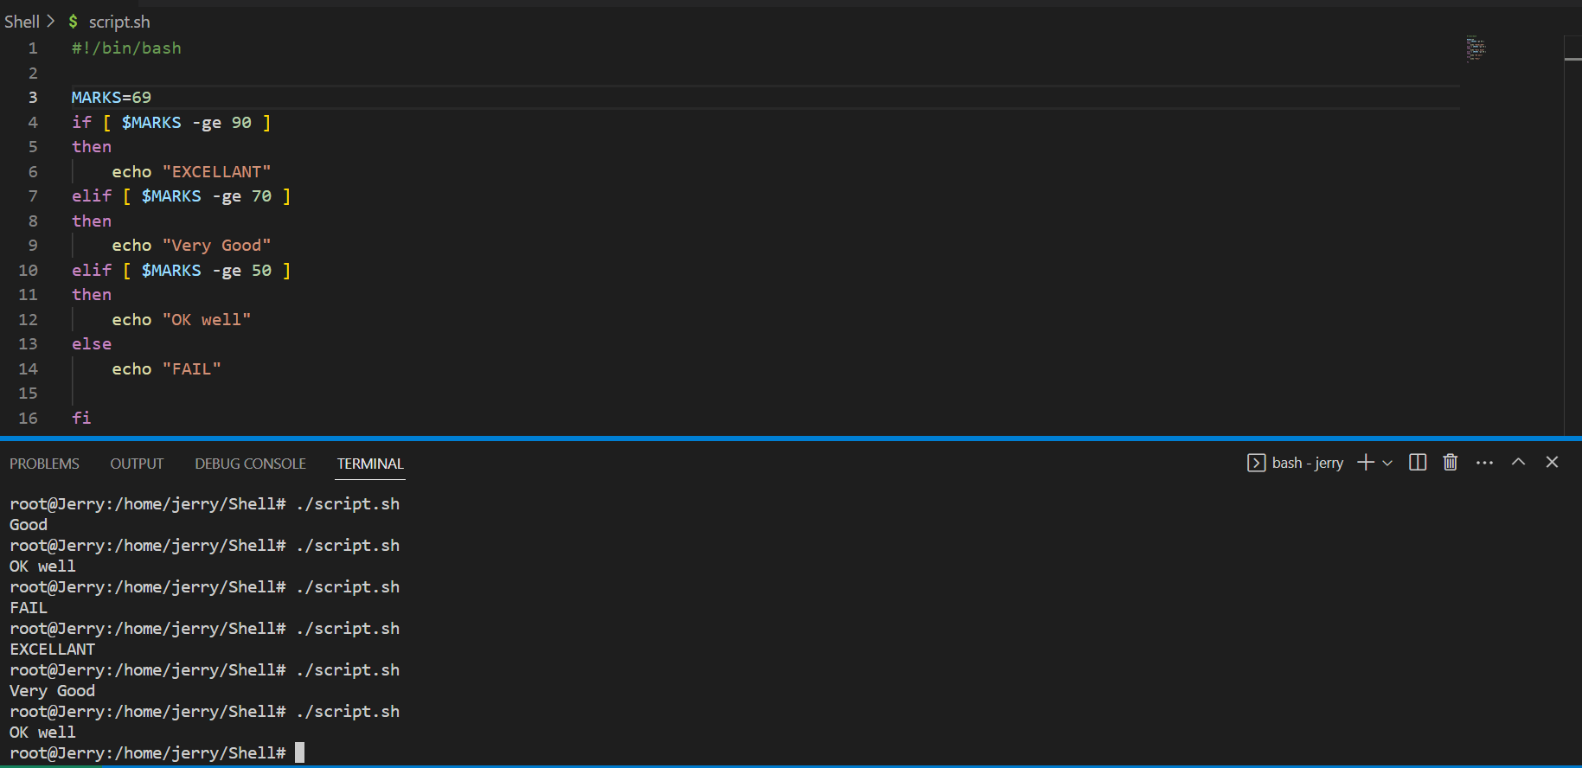

1. Case Conditional statement with strings:

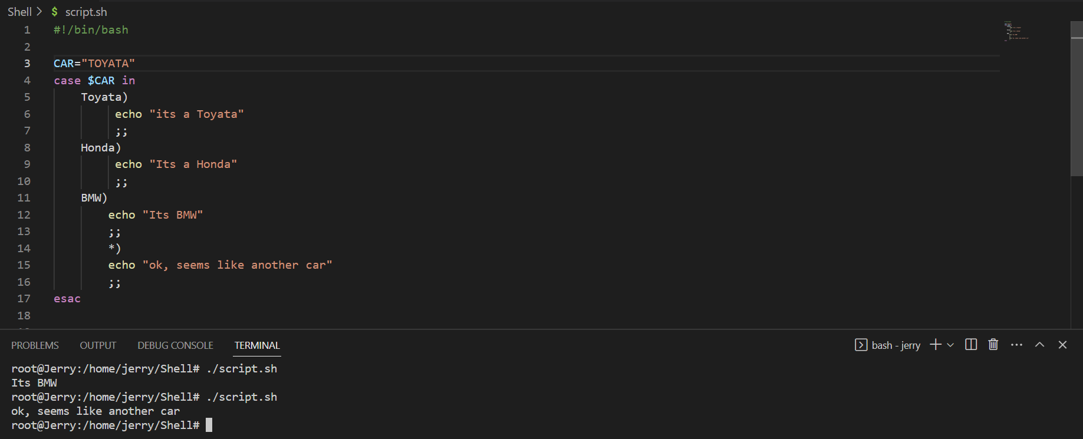

1. Case Conditional with Wildcards:

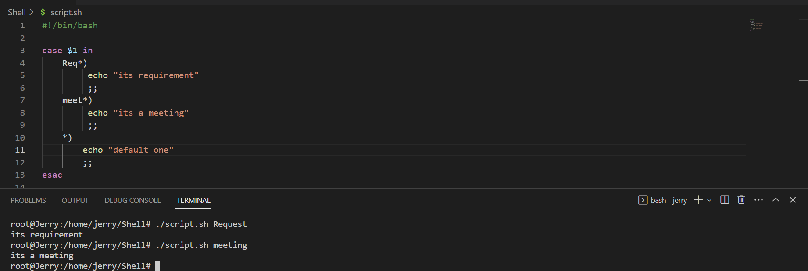

1. Execute a command and capture STDOUT :

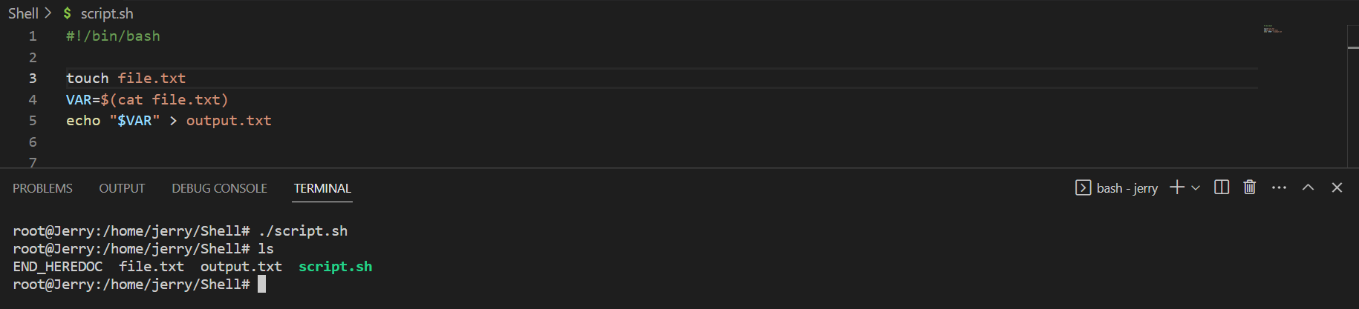

1. Bash Exec command for hellow world:

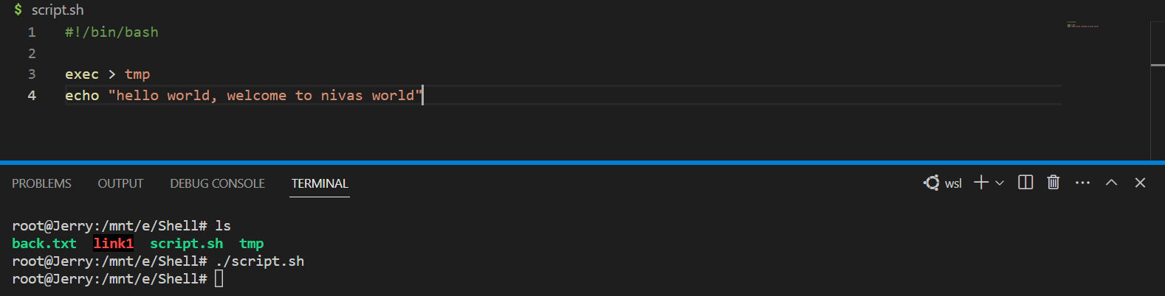



1. Eval Command:

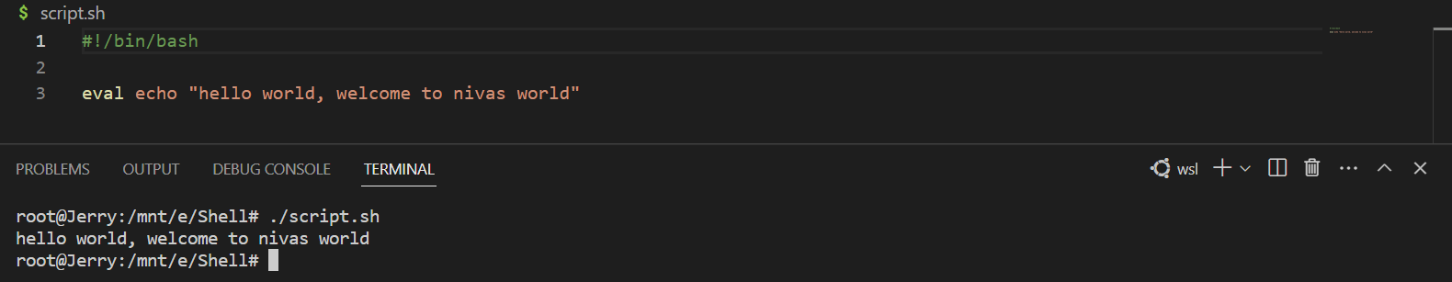

1. For Loop Commands:

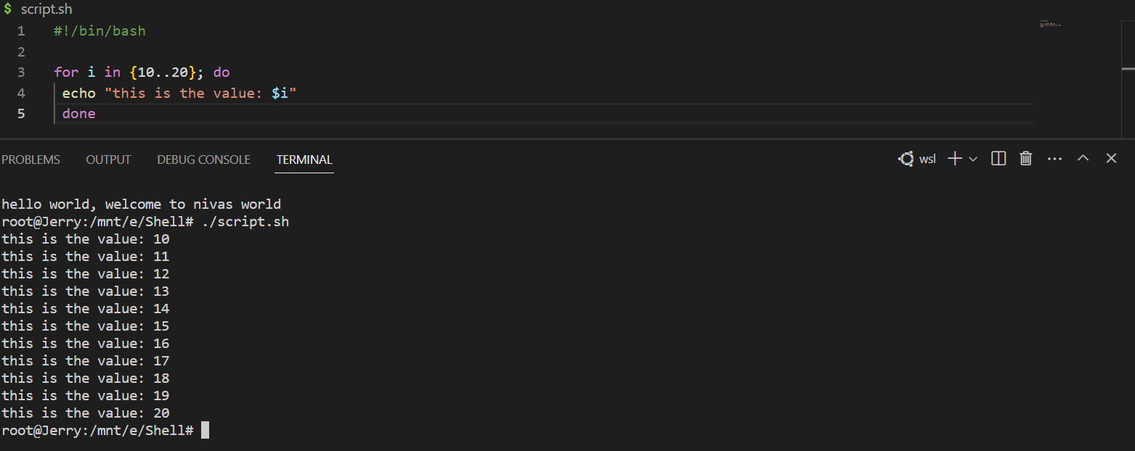

1. SED command:

Sed ‘s/here/where/’ file.txt

1. Tar file steps: